**Final project: summary description**

Application name: SmartUM.

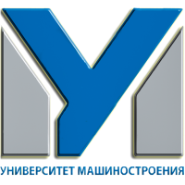

Logo:

Description:

SmartUM – android application of the Moscow State University of Mechanical Engineering (MAMI). Application contains the actual and the most interesting information for applicants, students and employees of the University of Mechanical Engineering.

Features:

* information about University;
* news section (parsing of RSS feed)

RSS source:

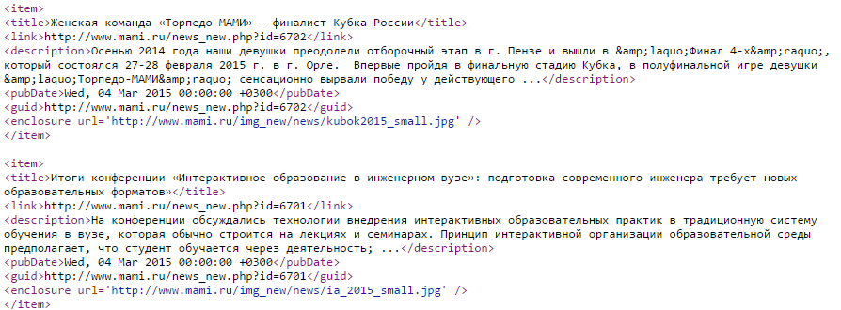

* information for applicants;
* creation, edit and delete information about hometasks;
* useful contacts and links.